Linguine Love Affair
Inspired by


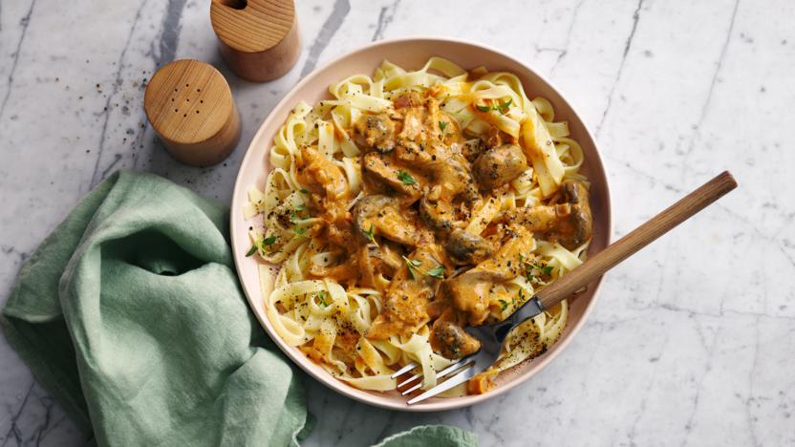
DID YOU KNOW?
“Peas are high in fibre, protein, vitamins, and minerals. They also contain antioxidants and anti-inflammatory compounds. Looks like they are saving the day, one pod at a time!”

Nutrition – Total / Per Serving
Calories: 1329kcal / 664.5kcal
Carbohydrates: 213g / 106.5g
Protein: 48g / 24g
Fat: 31g / 15.5g
Fibre: 19g / 9.5g
Sugar: 34g / 17g
Ingredients
180g of linguine
15g of almonds
20g breadcrumbs
2 cloves of garlic
40g onion marmalade
1 vegetable stock paste
100ml of water
200g of peas
20g hard Italian style cheese
100ml cream






Good for:

Star Rating:





Method

Step 1 - Preparation
Boil the kettle.
Crush/chop the almonds.
Grate the garlic.
Make the stock by mixing the stock paste and the water.

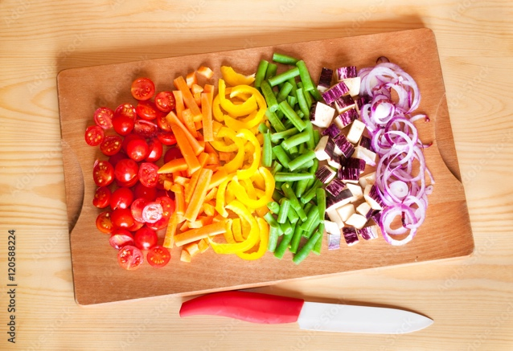
Step 2 – Pasta & Mushrooms
Cook the pasta according to the package instructions.
Heat the oil in a frying pan.
Add the breadcrumbs and almonds.
Fry until toasted (~3 mins).
Remove the breadcrumbs and almonds and place on a separate plate for later.
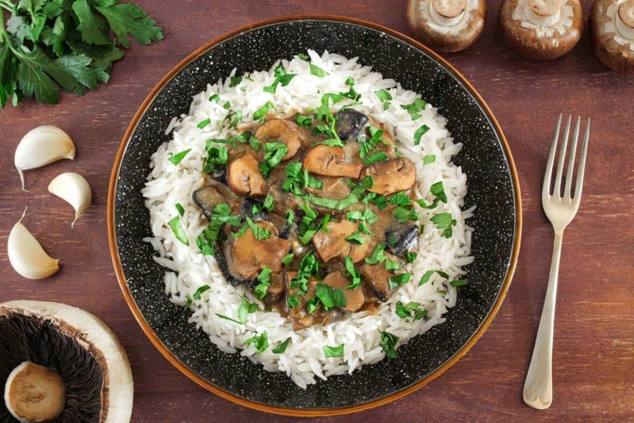
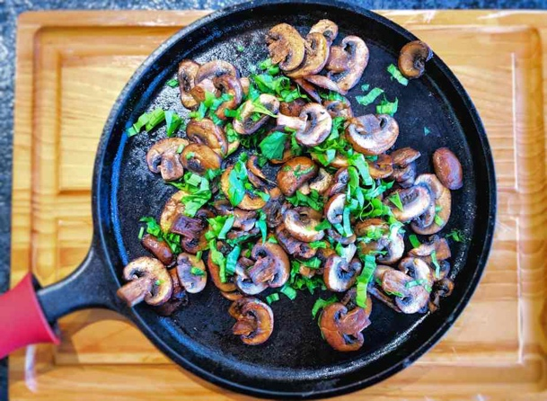
Step 4 – Bring it Together
Turn the heat off for the frying pan.
Season with salt and pepper.
Mix well and serve.
Sprinkle the toasted breadcrumbs and almonds.

Enjoy!
Step 3 – Fry it & Make it Saucy
Put the now empty frying pan back on the heat and add oil.
Add the onion marmalade and garlic and stir for 1 minute.
Add the stock to the frying pan and bring to the boil to reduce (~4 mins.).
Add the peas, cream, and pepper to taste and stir for 2 minutes.
Drain the linguine and add to the frying pan.
Add the hard Italian style cheese.

